***EmblemHealth - Premiums***

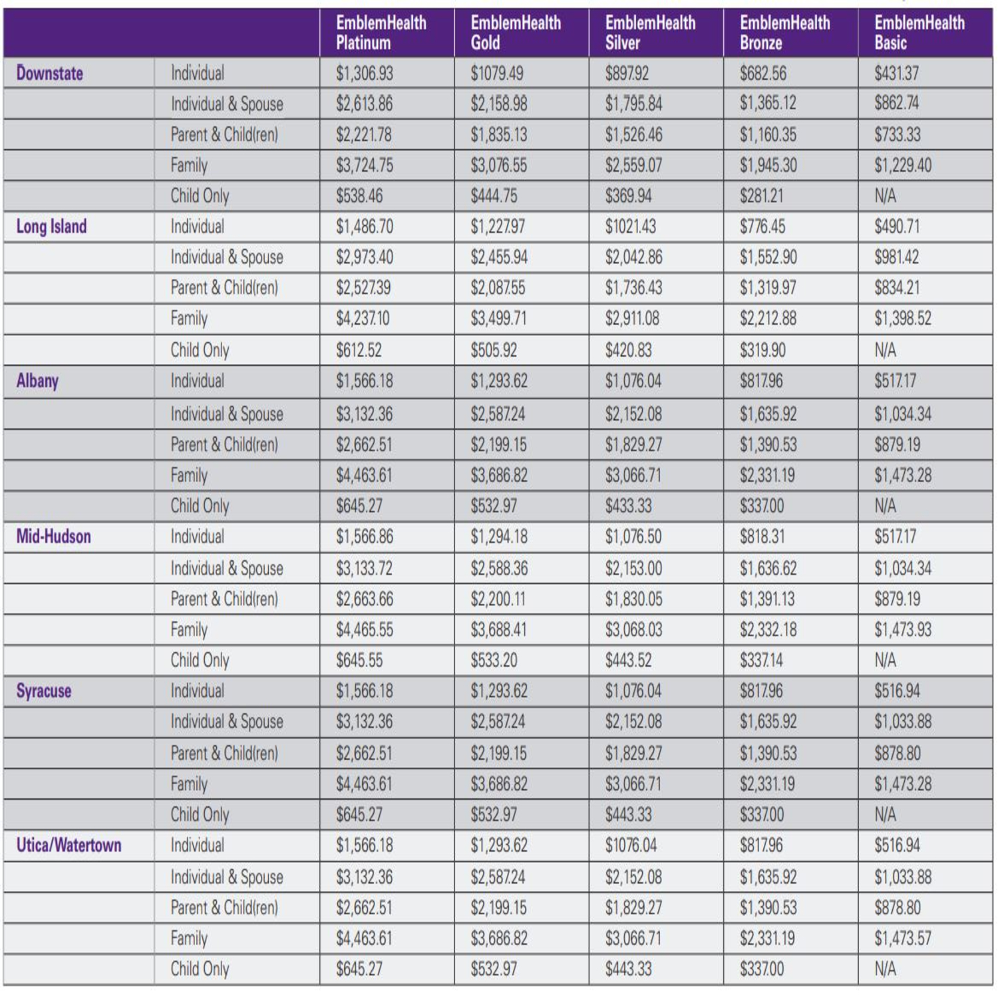

***EmblemHealth - Premiums (> 30 Years of A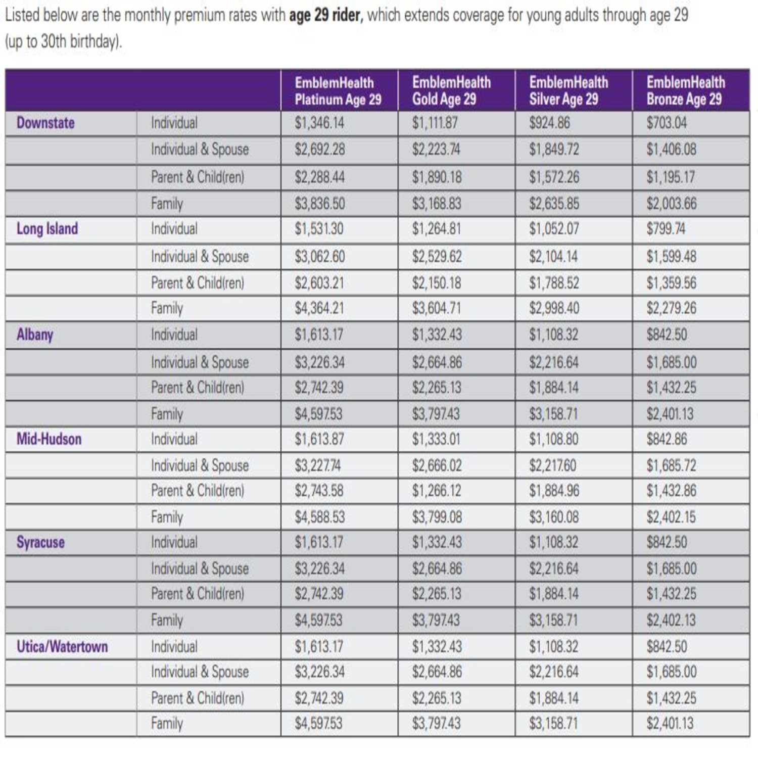ge)***

*\*These charts are saved onto my hard drive, in the event some of these are difficult to read.*

*\*\*Emblem Health has a lot of variable information as well, however it provides coverage to practically all of NYC rather than western NY.*

***BlueCross BlueShield - Premiums***

|  |  |  |  |  |
| --- | --- | --- | --- | --- |
|  | ***Individual*** | ***Individual + Child(ren)*** | ***Individual + Spouse*** | ***Family*** |
| **Bronze** | **$413.81** | **$703.48** | **$827.62** | **$1,179.36** |
| **Silver** | **$563.65** | **$958.21** | **$1,127.30** | **$1,606.40** |
| **Gold** | **$724.17** | **$1,231.09** | **$1,448.34** | **$2,063.88** |
| **Platinum** | **$883.54** | **$1,502.02** | **$1,767.08** | **$2,518.09** |

*\*Attempted to look into Aetna and Fidel Care, however both insurances either had information that was difficult to obtain or had extremely variable level of premium cost, making the scope of the project a bit too overwhelming.*

*\*\*BlueCross only provides to Western New York.*